Workshop on “Microteaching”
05/07/2012
The program began at 3.00pm.
Prof. Dr. Raju Antony, HOD, Community Medicine & Coordinator, MET Unit welcomed the audience.
Principal and Officer in charge, MET unit Commodore Dr. M. J. John, gave the introductory remarks and inaugurated the programme. He spoke on the importance of the workshop. He stressed the need for the teacher’s training and requested the faculty to get involved in research activities and to publish papers.

Dr. Suchanda Sahu, HOD – Biochemistry, presented the details of Microteaching starting with the definition, meaning, methodology, advantages and skills practiced. She explained the procedure to conduct a microteaching session. There were 2 presentations planned to be conducted during the work shop.

The first presentation was by Dr.Seema L. Jawalekar, Assoc. Prof - Biochemistry, on “Obesity and its effects”. 5 teachers from among the audience were given the feedback forms to fill up independently. They were:
Dr.Sumangala, Prof & HOD – Pathology
Dr.Ambika Bai, Prof & HOD – OBG
Dr.Indira, Prof & HOD – Pulmonology
Dr.Prasad, Prof & HOD – Surgery
Dr.Mary Franklin, Prof & HOD – Pediatrics
Dr.Seema L. Jawalekar presented the topic for 5 minutes using audio visual aids.
After the presentation Dr. Prasad gave a feedback regarding the speaker’s positive and negative points.

The next presentation was by Dr. Raju Antony. He took class on effective communication for 5 minutes. Before presentation a few faculty members from among the audience were given the feedback forms for filling.

They were :
Dr.Dharmaratnam – Prof & HOD Dermatology
Dr.Anoop Sinha, Assoc. Prof &, Microbiology
Dr.Isaac, Asst Prof, Anesthesia
Dr.Asha Augusty., Asst Prof, Biochemistry.
Dr. Anoop summarized the feedback giving speaker’s positive and negative points.
Medical Superintendent Dr. Satheesh G Prabhu gave the concluding remarks. He pointed out the importance of similar sessions in future to improve quality of teaching.
The participants requested for having a session on “role play” during one of the future sessions.
The workshop was attended by many faculty members from different departments.
The session ended with vote of thanks by Dr. Raju Antony.

Basic Research Methodology Course
September 2012 to January 2013
We have started the Basic research Methodology Course on 19th September 2012. This programme was inaugurated by Executive Director Col Ramesh and Principal Surg Commodare Dr M J John.
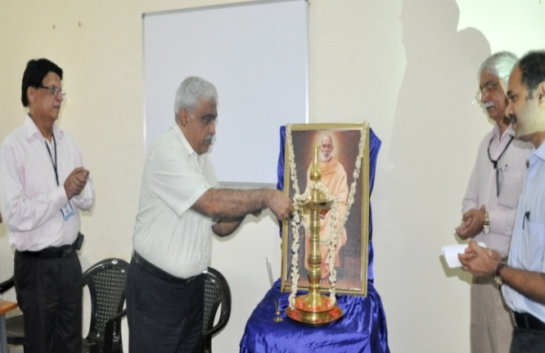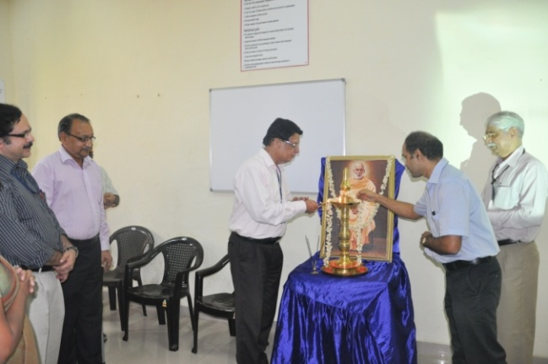
This is a course being conducted by SNIMS in collaboration with Christian Medical College, Vellore and Medical College, Thiruvananthapuram. This course is not to make an expert in epidemiology or research; however, few short-term and long term outcomes enumerated below are expected from the participants. We have started with few lectures, group activities, participant presentations and planning for a one day workshop. The sessions are conducted every Wednesdays from 2PM to 3PM. We have completed the following topics - Introduction, Research Designs, Formulating research questions, Clinical Trials, Writing a research protocol and Ethics and research.

The main objective of the course is to enable the participants to develop research proposals. Participants should identify their topics of interest (that is relevant also) preferably ahead of the commencement of sessions. This requires some ground work- like literature search and collecting statistical data etc. This research concept has to be further refined and shaped into a research question and forms the basis for developing the study protocol. It is ideal that each participant finally come out with a protocol; however the sessions on protocol development and presentations will be conducted as group activity.
In addition to protocol development, there will be sessions for facilitating critical reading of published articles and manuscript writing.

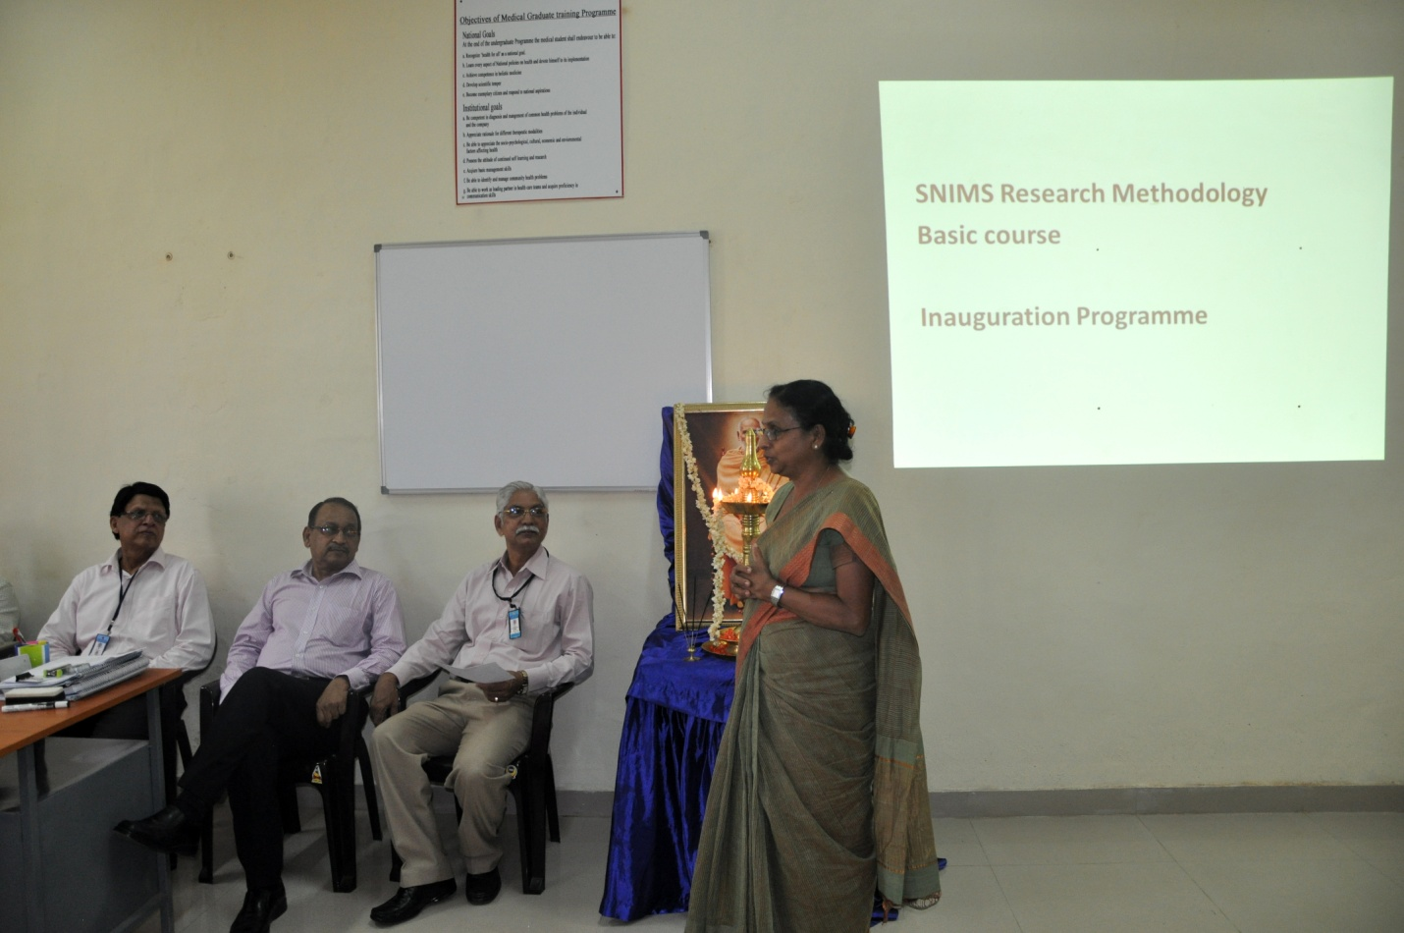

The research protocol development can be achieved by a step wise approach as listed below.
- Identify a research topic
- Formulate the research question
- Outline the study plan – each step
- Develop a questionnaire / Proforma
- Develop informed consent form
- Prepare time line
- Prepare budget with justification
- Methods for quality control
Study protocols will vary based on the study design. Formats for protocol preparation will be available as soft copy.
ASTICON 2012
Nov 2nd to 4th 2012
The Department of Dermatology Venerology and Leprology in association with the medical education and technology unit conducted a national conference of sexually transmitted diseases and HIV under the leadership of Dr A D Dharmarathnam. This was the 36th National conference of Indian Association for the Study of Sexually Transnitted Diseases & AIDS (IASSTD & AIDS) was conducted from November 2nd - 4th, 2012 at the Sree Narayana Institute of Medical Sciences, Ernakulam, Kerala. Speakers of repute from all institutes of national importance graced and spoke at the conference. The scientific programme is attached.

Scientific Programme
Friday, 02 NOV 2012
Continuing Medical Education - Past, Present And Future of STD & AIDS
Time | Topic | Speaker/Participants | Chairperson
STD PANORAMA
9:00 – 9:15 AM | Unusual manifestations of STDs | Dr. K Pavithran, Prof Emeritus, Former Prof & HOD Derm & Venereology, Calicut Medical College & Sr Consultant, Derm & Venereology MIMS, Kozhikode | Dr K Robins, Prof (Derm & Venereology), Academy of Medical Sciences, Pariyaram, Kannur
9:15 - 9:30 AM | STD's then and STD's now | Dr Rachel Mathai, Former Prof & HOD Derm & Venereology, Christian Medical College, Vellore
9:30 – 9:45 AM | Hurdles in STD practice | Dr N Usman, WHO Consultant (Venereology), Chairman, Technical Resource Group (STD), NACO
9:45 – 10:00 AM | Preventive strategies for STDs - a different perspective | Dr Bhushan Kumar, Former Prof & HOD Derm & Venereology, PGIMER, Chandigarh
10:00 – 10:15 AM | Discussion
HIV: EXPERT VIEWPOINTS 1
10:15 - 10:30 AM | STD and HIV – a physician's perspective | Dr R N Sharma, Prof & HOD Medicine, AIMS, Ernakulam | Dr Kunjamma George, Prof & HOD Medicine, SNIMS, Ernakulam
10:30 -10:45 AM | IRIS in HIV setting | Col (Dr) Rajesh Verma, Prof & HOD Derm & Venereology, Armed Forces Medical College, Pune
10:45 –11:00 AM | Stigma and discrimination towards HIV/AIDS | Dr Raju Antony, Prof & HOD Community Medicine, SNIMS, Ernakulam
11:00 - 11:15 AM | Primary Neurological involvement in HIV | Dr Anand Kumar, Prof & HOD Neurology, AIMS, Ernakulam
11:15 –11:30 PM | Newer approaches to HIV prevention | Dr Ajithkumar K, Addl Prof Derm & Venereology, Thrissur Medical College
11:30 – 11:45 AM | Discussion
CAMEO
11:45 - 12:00 Noon | Unusual sexually transmitted diseases and related genital conditions | Dr P M Abdul Gafoor, Consultant Dermatologist, Indira Gandhi Co-op Hospital, Ernakulam | Dr S Murugan, Former Prof & HOD Venereology, Tirunelveli Medical College & GMKMC, Salem
12:00 – 12:15 PM | Syndromic approach to STD management | Dr K Mahadevan, Prof & HOD Venereology, Coimbatore Medical College Hospital, Coimbatore
12:15 - 12:30 PM | Disseminated gonococcal infection | Dr MS Sadeep, Prof & HOD, Derm & Venereology, Govt Medical College Hospital, Kottayam
12:30 – 12:45 PM | Discussion
12:45–1:30 PM | LUNCH
VIRAL STD's
1:30 - 1:45 PM | Viral infections – lessons from the past | Dr Laxmi V Nair, Former Prof & HOD Derm & Venereology, Calicut Medical College, Professor & HOD (Derm & Venereology), KMCT Medical College, Kozhikode | Dr C Balachandran, Prof & HOD Derm & Venereology, KMC, Manipal
1:45 – 2:00 PM | HPV - today and tomorrow | Dr Somesh Gupta, Assoc Prof Derm & Venereology, AIIMS, New Delhi
2:00 - 2:15 PM | HPV and HIV | Dr Susanne Pulimood, Prof & HOD Derm & Venereology, Christian Medical College, Vellore
2:15 – 2:30PM | HSV serology – present day relevance | Dr Rajiv Sridharan, Prof & HOD Derm & Venereology, Academy of Medical Sciences, Pariyaram, Kannur
2:30 - 2:45PM | Condyloma acuminatum – practical management strategies | Dr Rema Devi TJ, Sr Consultant Derm & Venereology, KIMS Hospital & PRS Hospital, Trivandrum
2:45 – 3:00 PM | Discussion
ROVING EYE
3:00 – 3:15 PM | Sex in geriatric population – A myth or reality? | Dr George Paul, HOD Geriatrics, AIMS, Ernakulam
PG QUIZ PRELIMS
3:15 – 4:00 PM | PG Teams from various colleges |  | Dr Rajesh Sankar, Sr Consultant Derm & Venereology, Cochin Hospital, Ernakulam
END OF FIRST DAY SESSIONS
VENUE: BLUE WATERS, CHERAI BEACH
7:00 - 8.00 PM | CULTURAL PROGRAMME
8:00 - 8.30 PM | CONFERENCE INAUGURATION
 | Prayer & Lamp Lighting
 | Welcome Address | Dr A D Dharmaratnam, Chairman, ASTICON 2012
 | Secretary's Report | Dr P Elangovan, Secretary, IASSTD & AIDS
 | Presidential Address | Dr Dinesh C Govil, President, IASSTD & AIDS
 | Inauguration & Awards Distribution | Surg R Adm John D'Souza, VSM Command Medical Officer, Headquarters, Southern Naval Command
 | Release of Souvenir | Dr Dinesh C Govil
 | Vote of Thanks | Dr J Sridhar, Organising Secretary, ASTICON 2012
8:30 PM Onwards | COCKTAILS & DINNER

Saturday, 03 NOV 2012 - Conference Day 1
8.30 AM - 9:30 AM | Dr HC Mohanty PG Quiz Competition | Teams 1, 2, 3, 4 Quizmaster : Dr Rajesh Sankar, Sr Consultant Derm & Venereology, Cochin Hospital, Ernakulam | Dr Rajiv Sridharan, Prof & HOD Derm & Venereology, Academy of Medical Sciences, Pariyaram, Kannur
Time | Topic | Speaker/Participants | Chairperson
ORATIONS 1
9:30 - 10:00 AM | RV Rajam Endowment Oration – “STDs and Pregnancy: a venereologist's quest” | Dr V K Jain, Prof & HOD Derm & Venereology, Pt BD Sharma PGIMS, Rohtak | Dr B Loganathan, Former Prof & HOD Venereology, Govt Royapettah Hospital & Kilpauk Medical College, Chennai, Sr Consultant Venereologist, Expo Clinic, Chennai
10:00- 10:30 AM | Institute of Venereology Silver Jubilee Oration – “Ethics in HIV – overlooked?” | Dr S Ambujam, Prof & HOD Derm & Venereology, Indira Gandhi Medical College & Research Institute,Puducherry
EXPERT VIEWPOINTS 2
10:30 - 10:45 AM | Biochemistry and immunology of HIV | Dr DM Vasudevan, Chairman, Medical Laboratory Services, AIMS, Ernakulam | Dr Bhushan Kumar, Former Prof & HOD Derm & Venereology, PGIMER, Chandigarh
10:45 - 11:00 AM | AIDS and the Heart | Dr N Sudhaya Kumar, Prof Cardiology, AIMS, Ernakulam
11:00 – 11:15 AM | Neurological complications in HIV | Dr Madhusudanan, Prof Neurology, AIMS, Ernakulam
11:15 – 11:20 AM | Discussion
HIV THERAPY
11:20 – 11:35 AM | Management of ART-experienced patients (more than 10yrs) | Dr DG Saple, Prof Derm & Venereology, Director HIV Clinical Research Programme, Human Health Care & Research Foundation | Dr Najeeba Riyaz, Prof & HOD Derm & Venereology, Calicut Medical College
11:35 – 11:50AM | Monitoring Antiretroviral Therapy | Dr Jayadev Betkerur, Prof & HOD Derm & Venereology, JSS Medical College, Mysore
11:50 – 12:10 PM | Treat and Cure HIV early Panel discussion on HIV/AIDS | Dr R Sajith Kumar, Chief of Infectious Diseases, Govt Medical College Hospital, Kottayam
12:10 – 12:45PM | Moderator: Dr J Sridhar, Consultant Derm & Venereology INHS Sanjivani, Kochi | Dr D G Saple, Dr R Sajith Kumar, Dr Jayadev Betkerur, Dr Radhakrishnan, Dr G Nandakumar
12:45 - 1:30 PM | LUNCH BREAK
1:30 – 2:05 PM | FREE PAPERS SESSION 1
 | Clinicoepidemiological study of STI at rural-based tertiary care  centre | Dr Abhishek Pilani | Dr K Shobanakumari, Prof Derm & Venereology, Govt Medical College Hospital, Kottayam
 | Adverse reaction to multiple antiretrovirals – is it ? | Dr Neha Sharma
 | Squamous cell carcinoma on a syphilitic gumma: a unique presentation | Dr Rahima Saleem
 | Pseudogranuloma herpeticum | Dr D Pratyusha Kolanuwada
NON-VIRAL STD'S
2:05 - 2:20 PM | Follow up of syphilitic cases: a case study | Dr P Elangovan, Prof & HOD Venereology, Govt Royapettah Hospital, Kilpauk Medical College & Hospital, Chennai | Dr Meera Bhagyanathan, Sr Consultant Derm & Venereology, Baby Memorial Hospital, Kozhikode
2:20 -2:35 PM | Changing trends in syphilis | Dr Kaushal Verma, Prof Derm & Venereology, AIIMS, New Delhi
2:35 - 2:50 PM | Mycoplasma genitalium – an emerging sexually transmitted pathogen | Dr Sunil Sethi, Addl Prof Medical Microbiology, PGIMER, Chandigarh, Vice Chairman, IUSTI Asia Pacific South Asia Subregion & Nodal officer, RNTCP Accredited Lab
2:50 - 3:05 PM | Lymphogranulomavenereum – resurgence | Dr G Nandakumar, Addl Professor, Dept of Pathology, Govt Medical College, Trivandrum
3:05 – 3:20 PM | Discussion
3:20 - 4:10 PM | FREE PAPERS SESSION 2
 | Whither venereology training in India? | Dr N Asokan | Dr Abdul Samad, Addl Prof Derm & Venereology, Govt Medical College, Trivandrum
 | HIV Prevalence among diagnosed MDR-TB patients in Dhaka, Bangladesh | Dr Kashi Kant Jha
 | Throwing some light on dark field microscopy for the diagnosis of syphilis in genital ulcer disease : a 15- year experience | Dr Sumathi Muralidhar
 | New insights into non-infectious inflammatory dermatoses in HIV infection community | Dr Betsy Ambooken
 | Community STI survey in turmeric district of Tamil Nadu | Dr R Rajesh
 | Periodic presumptive treatment – a step backward or forward? | Dr S Sreekanth
END OF SESSIONS DAY 2
VENUE: BOLGATTY PALACE AND ISLAND RESORT
6:30 – 7:30 PM | GENERAL BODY MEETING OF IASSTD & AIDS
7:30 PM Onwards | CULTURAL PROGRAMME AND DINNER

Sunday, 04 NOV 2012 - Conference Day 2
Time | Topic | Speaker/Participants | Chairperson
AWARD PAPER SESSIONS
8:30– 9:30 AM | Dr V Govindan Nair Memorial Award Paper Session
 | All that is genital is not venereal: Unusual cases with lesions on genitals | Dr Shaista Farooqui Kazi | Dr GC Rao, Founder Member & Hon. Treasurer, IASSTD & AIDS, Sr Consultant Venereologist, Chennai
 | Epidemiological trends in sexually transmitted diseases: a 5 year hospital based study | Dr Remya Raj R
 | Disseminated Kaposi sarcoma in HIV and Hepatitis B coinfected heterosexual male patient | Dr Manoj Agarwala
 | Clinico – investigative profile of cervicovaginal discharge in high risk women attending STI clinic in tertiary care hospital | Dr Swapna M
 | Asymptomatic neurosyphilis - an underrecognised facet of syphilis of unknown duration | Dr Anju K Balan
 | Characteristics of HIV patients who  are lost to ART follow up and  determine the reason for the same  – a study at Davangere, Central  Karnataka | Dr Amrita A Hongal
9:30– 10:30 AM | Dr P S Ranganathan Memorial Award Session
 | Ulcerating type 1 lepra reaction mimicking lazarine leprosy: an unusual presentation of immune reconstitution inflammatory syndrome in a human immunodeficiency virus infected patient | Dr Malcolm Pinto | Dr K Muhammad, Addl Prof Derm & Venereology, Calicut Medical College, Kozhikode
 | Investigating seasonal variations in gonorrhoea using graphical and ratio-to-moving average methods | Dr Manju Bala
 | Antiretroviral therapy (nevirapine) induced toxic epidermal necrolysis | Dr Veena Thimmappa
 | Emergence of drug resistant Tuberculosis: threat to TB and HIV control Programmes | Dr Badri Thapa
 | Child sexual abuse - a sensitive subject | Dr Aarthi M
 | Study on the prevalence and microbial profile of urethritis among men attending STD Clinic in a tertiary care hospital | Dr Balaji AVM
 | Study profile of male clients of female sex workers (FSWs) | Dr R Ramachandran
ORATIONS 2
10:30 - 10:45 AM | Sardari Lal Memorial Award 2012 “Determinants of rapid progression to immunodeficiency syndrome among people infected with human immunodeficiency virus” | Dr TS Anish, Asst Professor, Department of Community Medicine, Government Medical College, Thiruvananthapuram | Dr K Venkateswaran, Assoc Prof Venereology, Institute of Venereology, Chennai
EXPERT VIEWPOINTS 3
10:45 – 11:00 AM | Current perspectives in STI & HIV prevention | Dr YS Marfatia – Prof & HOD Derm & Venereology, GMC and SSG Hospital, Vadodara | Dr YS Marfatia – Prof & HOD Derm & Venereology, GMC and SSG Hospital, Vadodara
11:00 – 11:15 AM | Medicolegal aspects of STD & AIDS | Dr Uma Dethan, Prof & HOD, Forensic Medicine, AIMS, Ernakulam
11:15 – 11:40 AM | Thirty years of AIDS - lessons learnt and future challenges | Dr JK Maniar- Consultant in HIV Medicine, Jaslok Hospital & Research Centre, Mumbai
11:40 – 11:55 AM | Challenges in Management of HIV-2 infection | Dr JK Maniar- Consultant in HIV Medicine, Jaslok Hospital & Research Centre, Mumbai
11:55 – 12:10 PM | Current status of initiation of ART in HIV infected patients | Dr O C Abraham – Prof Medicine, Christian Medical College, Vellore
12:10 – 12:20 PM | Discussion
12:20 – 1:00 PM | AWARDS FUNCTION  INSTALLATION OF NEW PRESIDENT & OFFICE BEARERS  VALEDICTORY FUNCTION
END OF CONFERENCE

The photos of ASTICON 2012, Kochi have been uploaded on Picasa Web Albums. They can be accessed by clicking the links below. There are more photos-on-stage of individual Speakers - would be glad to email on request.

Day 1: CME Scientific sessions
https://picasaweb.google.com/107536070930719395420/Asticon2112012?authuser=0&amp;authkey=Gv1sRgCKuCm4KnqsGaUw&amp;feat=directlink

Day 1 afternoon: CME Inauguration by GCT Executive
https://picasaweb.google.com/107536070930719395420/AsticonCMEInauguration?authuser=0&authkey=Gv1sRgCOvlkc7Mraew0AE&feat=directlink

Day 1 evening: Conference Inauguration & Banquet (few photos)
https://picasaweb.google.com/107536070930719395420/Asticon2112012CheraiBeach?authuser=0&amp;authkey=Gv1sRgCM_Lt4v4maaJ9AE&amp;feat=directlink

Day 2: Conference scientific sessions
https://picasaweb.google.com/107536070930719395420/Asticon3112012?authuser=0&amp;authkey=Gv1sRgCIiv3u63pKmCmAE&amp;feat=directlink

Day 2 evening: GB Meeting & Banquet
https://picasaweb.google.com/107536070930719395420/Asticon3112012Bolgatty?authuser=0&amp;authkey=Gv1sRgCLmPsfXA4bGsqwE&amp;feat=directlink

Day 3: Conference scientific sessions
https://picasaweb.google.com/107536070930719395420/Asticon4112012?authuser=0&amp;authkey=Gv1sRgCJee5YLMxZ7TXA&amp;feat=directlink

Workshop in Basic Biostatistics
2nd December, 2012

Date Time | Topic | Faculty
2:12:2012 9.00 – 10.30 AM  10.45 – 11:00 AM  11.00 – 12:30 PM  12:30 – 1:00 PM  1:00 – 1:30 PM  1:30 – 3.15 PM  3:15 – 3.30 PM  3:30 – 4.30 PM | Basics of biostatistics, Types of variables, Confidence Interval, SD, SE ,Descriptive statistics  Refreshment  Sampling methods  Sample size calculation – basics, software demo  Lunch  Demo of common statistical software - demo on data entry, Data Manipulation  Refreshment  Hypothesis testing :Comparison of means | Mrs. Visali  Ms.Thenmozhi  Mrs.Visali  Ms.Thenmozhi  Ms.Visali

