REPORT ON CME PROGRAM IN LEPROSY CONDUCTED AT SREE NARAYANA INSTITUTE OF MEDICAL SCIENCES, CHALAKKA.
A Continuing Medical Education Program on Leprosy was conducted at this college on 6.9.2013 under the joint auspicious of departments of Dermatology, Community Medicine and Medical Education & Technology Unit. An Organizing committee was constituted for the smooth conduct of the program with the following members. Total 60 Doctors including PG students in Dermatology from a other medical colleges participated in the CME.
1. Dr. M.J. John - Principal
2. Dr. A.D. Dharmaratnam - Chairman, Organizing committee
3. Dr. Ambika bai, - Secretary, Organizing committee
4. Dr. Raju Antony - Convener
5. Dr. Satish G. Prabhu - Convener
6. Dr. P. Gopalakrishnan, Associate Professor in the Dept. of Community Medicine was given charge of the finance.
Dr. M.J. John, Principal inaugurated the function by lighting the lamp in the college auditorium at 8.40 AM on 6th September.
. The Principal stressed the importance of CME on leprosy and added that the cases of leprosy are on the increase in Kerala. He also mentioned that this CME will give an opportunity for the faculty members to discuss with specialists in leprosy who have vast experience in managing leprosy and wished all success for the CME . In continuation to the inauguration Dr. Dharmaratnam, HOD, Dermatology gave an introductory talk on leprosy.

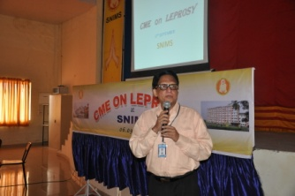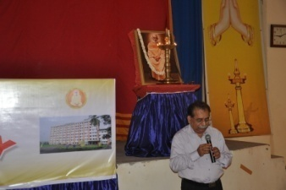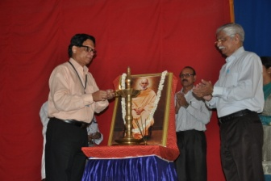

The first session started at 8.50 AM.
Dr. Dharamaratnam and Dr. Tommy Varghese, Medical Superintendent, chaired the session. Dr. Anoop Sinha, Associate Professor, Dept. of Microbiology presented a topic on “introduction to leprosy and lab. diagnosis”. He explained in detail various methods of laboratory diagnosis on leprosy.

2

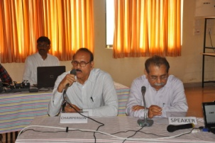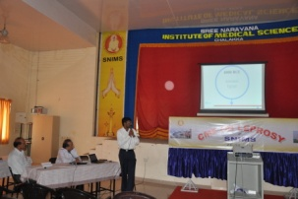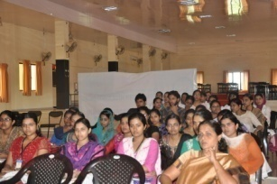

Session 2 was chaired by Dr. Sumangala, HOD, Dept. of Pathology.
Dr. Magdalin, Professor of Pathology explained in detail various aspects of pathology and pathogenesis’ of leprosy. Doubts were clarified immediately after the session.

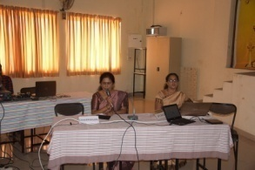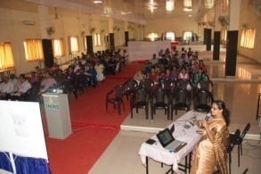

After tea break, Dr. Raju Antony, HOD, Dept. of Community Medicine chaired the next session on” the role of BCC in elimination of leprosy”.
Dr. Saritha Susan Varghese explained various aspects of communication with special emphasis on behavioral change. She said, though there are plenty of opportunity for health education, and there are experts who give health education using various improvised and modern methods, what is lacking is behavioural change. The need is to have sustained and committed efforts for behavioural change in the people. Only then we can achieve the expected results. Dr. Raju Antony quoted many examples to have effective communication, so as to have behavioral changes faster and better.

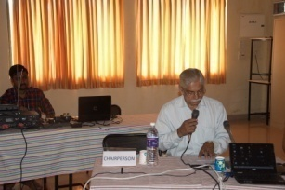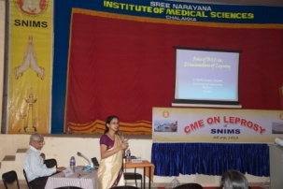
The next session was on “diagnosis and management of leprosy”. Prof. Dr. Ambika bai chaired the session. Prof. Dr. Sadeep and Prof. Dr. Sobhana Kumari, Dept. of Dermatology, Medical college, Kottayam gave detailed discussion on the topic. They gave a mention about stigma attached to leprosy which is making diagnosis and management difficult.
3
Dr. Ambika bai informed that unless the family and community fully accept the leprosy patients, elimination of leprosy will continue as a mirage. Therefore the present need is to have coordinated, cooperative, continuous and committed efforts to maintain leprosy in the elimination stage.

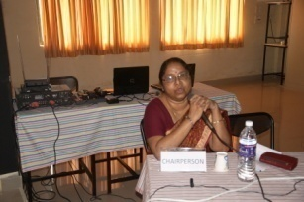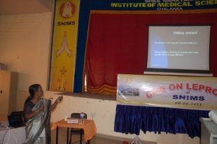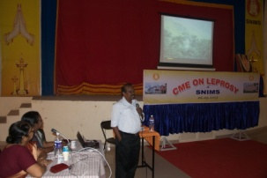

Next sessions were on leprosy along with other diseases.
Prof. Dr. Mohanan K.R., HOD Dept. of Orthopedics SNIMS chaired the session on “leprosy and systemic diseases”. Prof. Dr. N.L. Sarma and Prof. Dr. Ganapathi Rao explained various aspects of leprosy and several systemic diseases. They also mentioned about liver and bone changes in leprosy. Several doubts were clarified. This session was prolonged up to 1.45 PM as there were many doubts raised by participants.

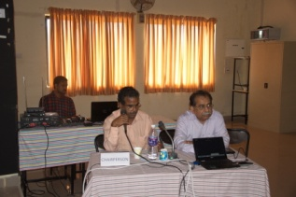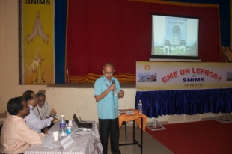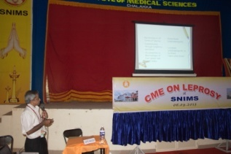

After lunch break, the next session started by 2.30 PM on the topic “Neuritis and surgical aspects of leprosy”. Prof. Dr. Satish G. Prabhu chaired the session.
The speakers were Prof. Dr. Anandakumar, HOD, Neurology and Prof. Dr. Gopalakrishnan, HOD, Surgery from Amritha Institute of Medical sciences, Kochi. They explained various surgical and neurological aspects of leprosy. Dr. Satish Prabhu also added various surgical aspects of leprosy.

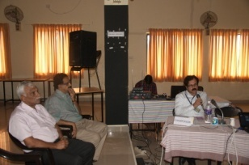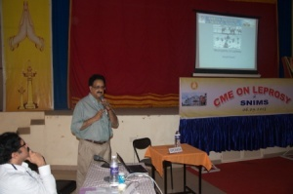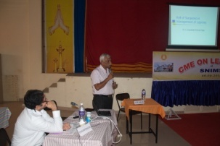

4
The next session was on “Drugs in leprosy and therapeutics” which was chaired by Dr. K.V. Nataraja, Professor of Pharmacology, SNIMS and Dr. Naveen, Asst. Professor of Pharmacology, SNIMS gave the talk on the subject.

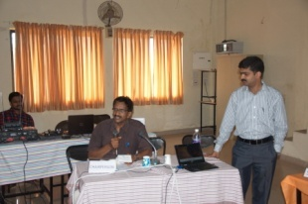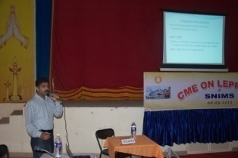

The session was on “relapse, re-infection and reactivation of leprosy”. Dr. Dharmaratnam chaired the session.
The speakers were Dr. Vineetha Varghese Associate Professor, dept. of Dermatology, and Dr. David Puthukkadan, Associate Professor of Dermatology.

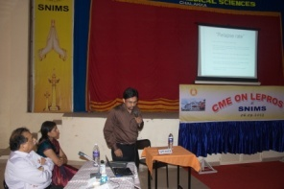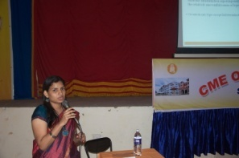

The last session on” “Stigma & discrimination and current status of leprosy” was chaired by Dr. Haseena Mohammed, District Medical Officer, Ernakulam and Dr. Raju Antony, HOD, Community Medicine, SNIMS.
The speakers were Dr. Dalia V.S. Deputy D.M.O. Ernakulam and Dr. P. Gopalakrishnan, Associate Professor, Dept. of Community Medicine, SNIMS. Dr. Dalia talked on stigma attached to leprosy in which she highlighted the importance of the activities to remove stigma in the community for better treatment compliance and eradication of leprosy.
Dr. Gopalakrishnan talked on present status of leprosy globally, nationally and locally and mentioned about the increase of cases during the year 2012 compared to the status during the preceding ten years.

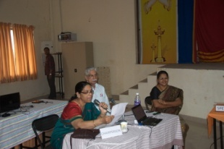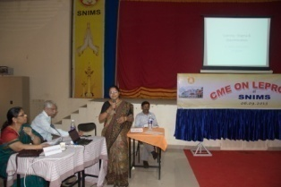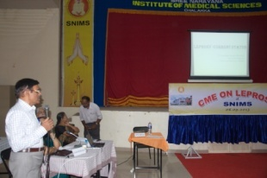
5
In the concluding session, Dr.M.J. John, Principal congratulated the organizing team for their untiring efforts with which the CME was well conducted.He thanked the chairpersons, speakers and participants. The Principal also appreciated the efforts made by the departments of Dermatology, Community Medicine and the Medical Education unit of this college.

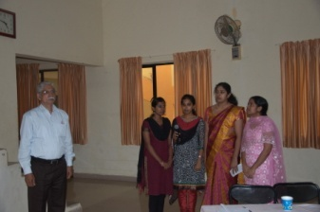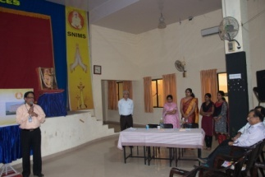

Dr.Raju Antony, HOD Dept. of community medicine thanked all those have participated and helped for the smooth conduct of the programme. He added that he is grateful to the G.C.T. team for the help and guidance given to make the CME a reality. He thanked again all the participants, chairpersons, speakers and all those who helped to plan and conduct the CME.

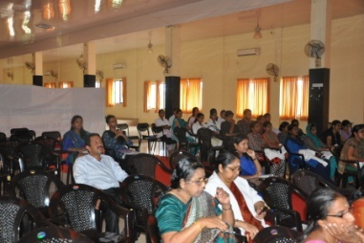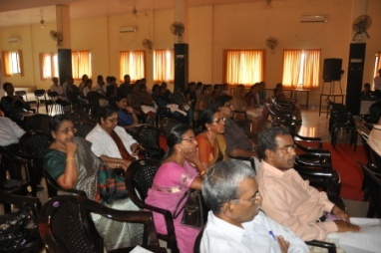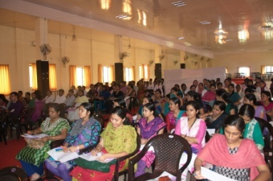

Dr. M.J. John,
Principal.

